Division of Emergency Medicine
800 Commissioners Rd East • London, Ontario • N6A 5W9 • Canada
Telephone: (519) 685-8500 ext 76089 • Fax: (519) 667-6769

PARTICIPANTS NEEDED FOR RESEARCH STUDY EXAMINING
3D PRINTED PULSE OXIMETER PROTOTYPE

A pulse oximeter is a sensor device placed on the finger to measure oxygen levels in the blood.

We are looking for healthy, non-smoking adult volunteers over the age of 18 to take part in a study to calibrate and validate a newly designed, 3D printed pulse oximeter.

If you are interested and agree to participate you would be asked to: have an arterial catheter inserted into your wrist to measure the oxygen levels in your blood samples; have the experimental, 3D printed pulse oximeter and a control oximeter placed on your fingers; wear a breathing mask to deliver a mix of nitrogen and oxygen at a progressively different ratios under careful monitoring by an experienced emergency physician.

Your ONE TIME participation will take 60 minutes of your time. You will not be compensated for your participation in this study.

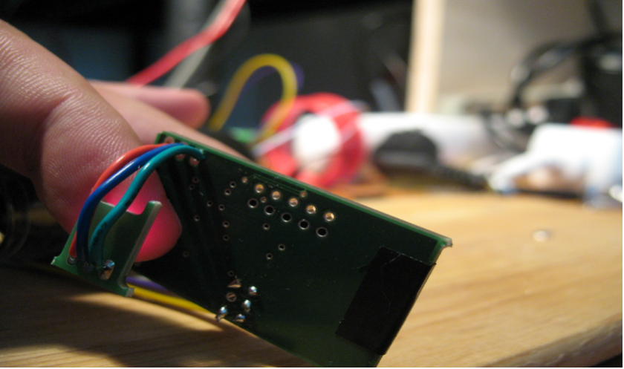
If you are interested in participating, please e-mail Dr. Tarek Loubani (tlouban@uwo.ca) with any questions or for more information.

